Temasek Polytechnic

School of Informatics and IT

**Diploma in Information Technology (IT)**

Software Design Specifications (DS)

**Project Particulars**

|  |  |
| --- | --- |
| **Tutor** | Qi Yutao |
| **Class** | P04 |
| **Project Title** | Hotel Management System |

**Project Team’s Particulars**

|  |  |
| --- | --- |
| **Matric Number** | **Student Name** |
| 1702378I | **Lee Jing** |
| 1705978C | **Koh Jia Hui** |
| 1705766B | **Lee Choon Loong** |
| 1603305B | **Toh Chien Yuan** |

Revision History

|  |  |  |  |
| --- | --- | --- | --- |
| **Date** | **Version** | **Description** | **Author** |
| 2/1/2019 | 1.1 | Added Architecture Design | Lee Jing |
| 4/1/2019 | 1.2 | Added Database Design | Koh Jia Hui |
| 5/1/2019 | 1.3 | Added Program Design | Toh Chien Yuan |
| 6/1/2019 | 1.4 | Added User Interface (UI) Design | Lee Choon Loong |

**Table of Contents**

**DISTRIBUTION OF WORKLOAD**4

**ARCHITECTURE DESIGN**4

**USER INTERFACE(UI) DESIGN (use the same as SRS)**5

**PROGRAM DESIGN**19

**DATABASE DESIGN**23

**REFERENCES**28

# DISTRIBUTION OF WORKLOAD

|  |  |
| --- | --- |
| **Design** | **Members** |
| Architecture Design | Lee Jing |
| User Interface(UI) design | Lee Choon Loong |
| Program Design | Toh Chien Yuan |
| Database Design | Koh Jia Hui |

# 

# ARCHITECTURE DESIGN

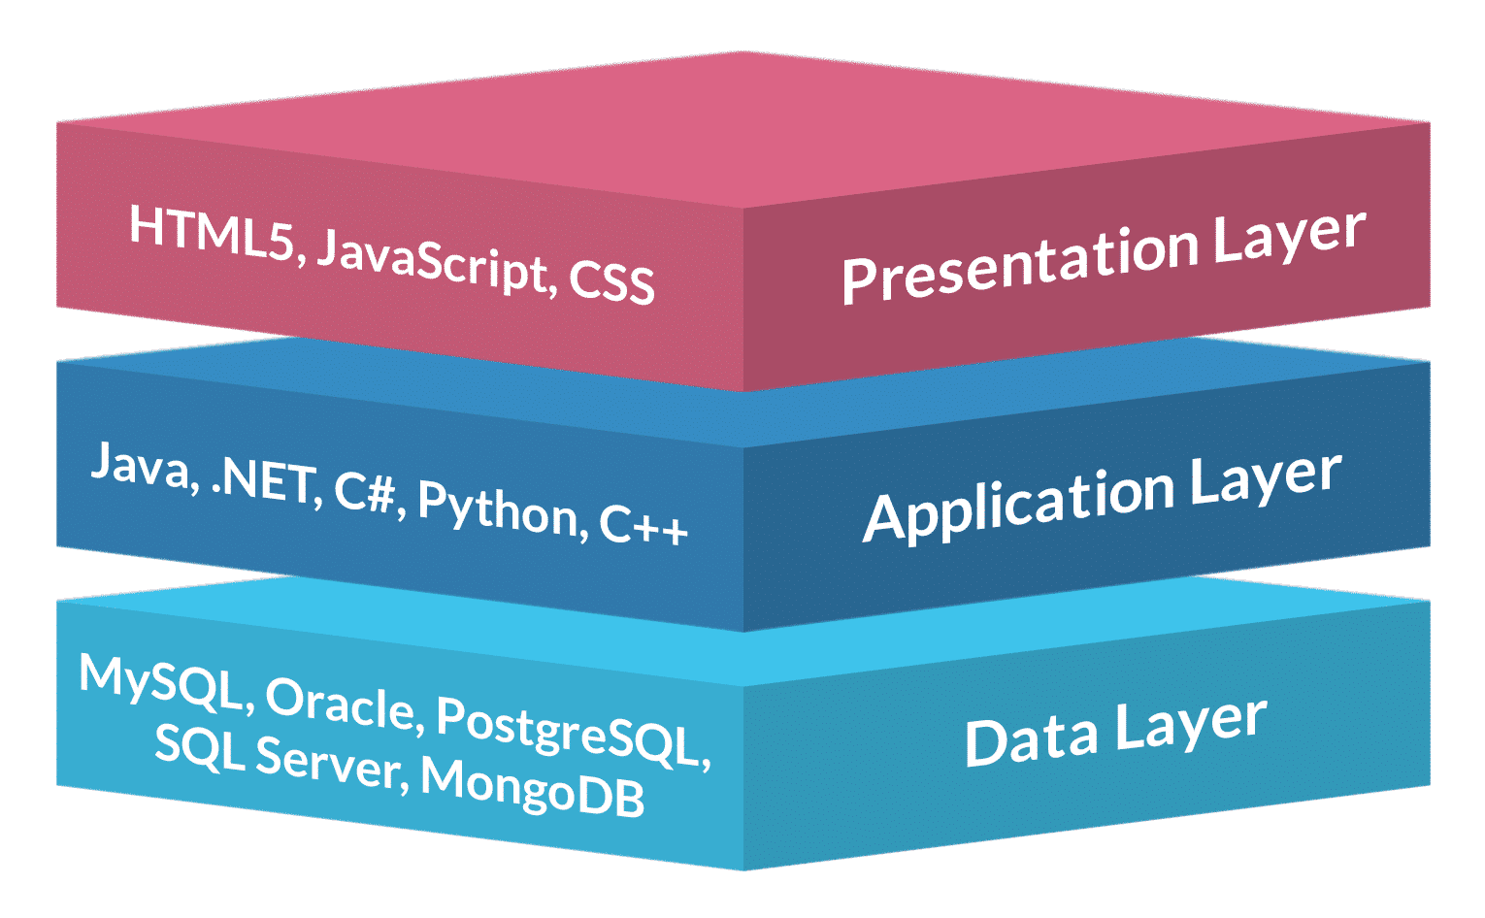

We will be using 3-tier architecture for the hotel management system. The above diagram shows the architecture design of the system.

In the system, the solution will be hosted in the cloud Azure which is hosted by Microsoft. Logic and Database tier will be hosted separately as well. By applying 3-tier architecture, the system will be accessible through anywhere as long as the web browser is available, causing the system accessibility to be very flexible. With the system being hosted by different vendors online, Mr. Wang would not have to worry about hardware problems like physical database server down as the vendors will be taking care of the problems.

For the presentation tier, we will be using CSS, HTML and JavaScript. We will be using JavaScript framework like Knockout JS or Angular to implement Single Page Application (SPA) which ensures the browser to load to another html page faster, enabling users to skip waiting time. We will also be implementing bootstrap framework to design the style of the website.

For the business logic/application tier, we will be implementing the web application using ASP.NET, using Model-View-Controller (MVC) which is an architectural pattern that separates the application into view, data and business logic. By doing so, the application’s code would not be squeeze into one big code, hence the development process would be faster as more people can work on the codes. We will also be using Web API, such as AJAX which helps to retrieve data, to enable the client tier to consume data

In the database tier, we will be using Microsoft SQL Server (MSSQL) to store all the data. MSSQL is a relational database, which enables users to manage predefined data relationships across multiple database tables, causing the extraction of specific information for reports to be easier and more accurate.

# USER INTERFACE(UI) DESIGN

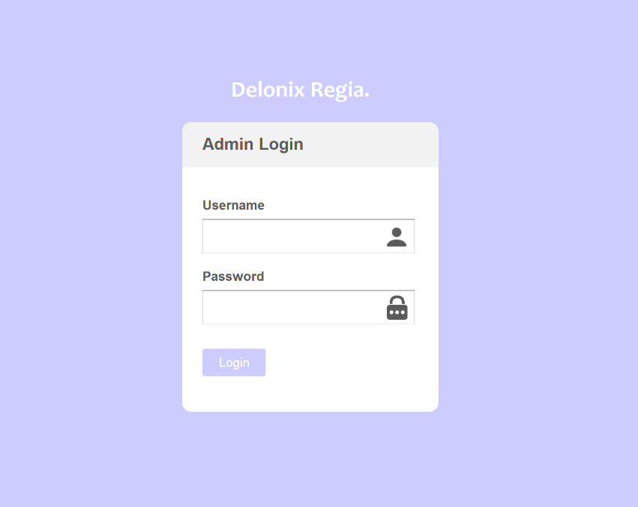

1. **Admin panel login page**

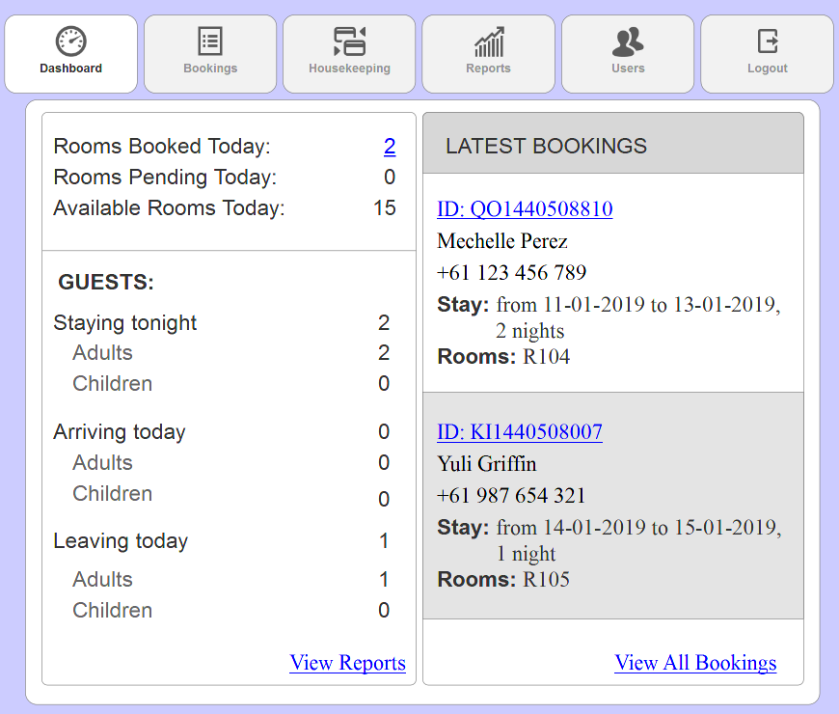

**2. Homepage (Dashboard)**

* Words with **blue underline** are link that will be redirected to another webpage
* Clicking the number of ‘Rooms Booked Today’, ‘ID’ of latest booking and ‘View All Bookings’ will redirect user to ‘Bookings page’
* Click ‘View Reports’ will redirect users to ‘Reports page’

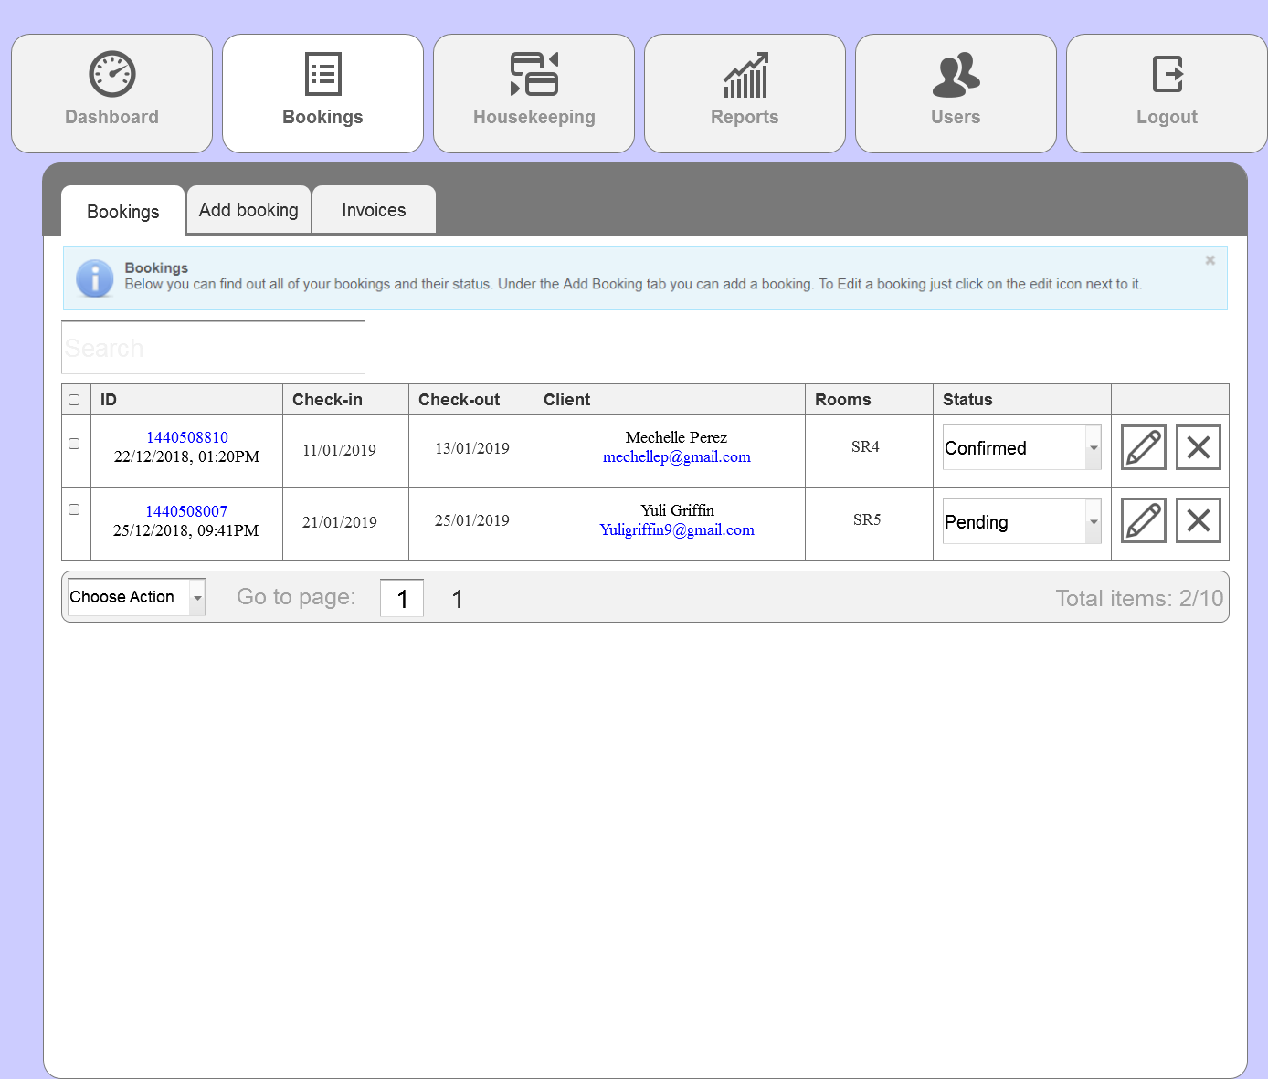

**3. Booking page**

* Client status depend on whether they have made deposit payment
* Status with confirmed represent that user had made deposit payment while status with pending represent that user have not make deposit payment
* Admin or receptionist can tick the checkbox of client to ‘Choose Action’ from the bottom navigation to ‘Delete selected’ or ‘Export’ (refer to 3i.)
* A warning message will be prompted if user did not tick any checkbox and click ‘Delete selected’ (refer to 3ii.)
* A warning message will be prompted upon clicking ‘Delete selected’ (refer to 3iii.)

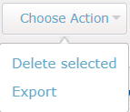

**3i. Choose Action**

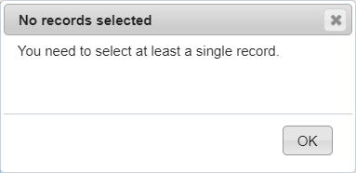

**3ii. Warning message**

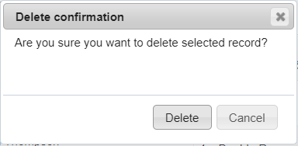

**3iii. Warning message**

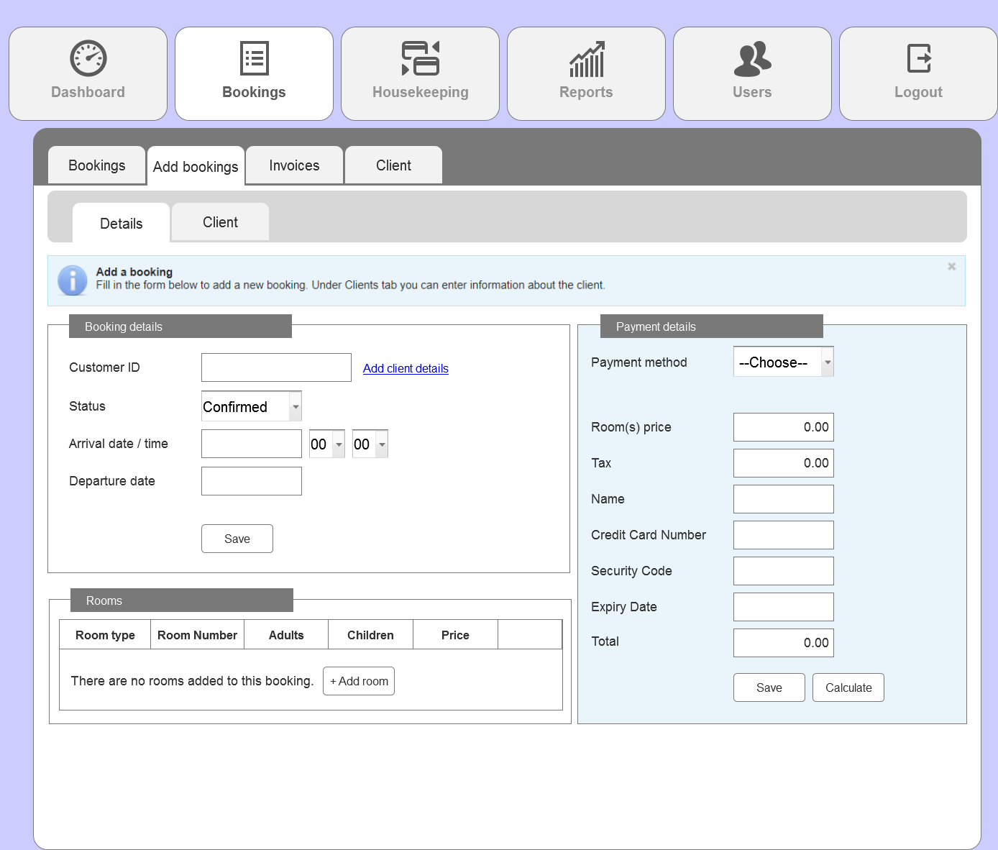

**3.1 Add bookings**

* This page can also be accessed by the receptionist if client choose to make walk-in reservations
* Clicking ‘Add client details’ will redirect user to the ‘client’ tab to let user fill in the particulars of client (annex 3.2)
* If user click on ‘Save’ button but does not have form filled up/ empty text field, user will be prompt with warning (refer to 3.1i)

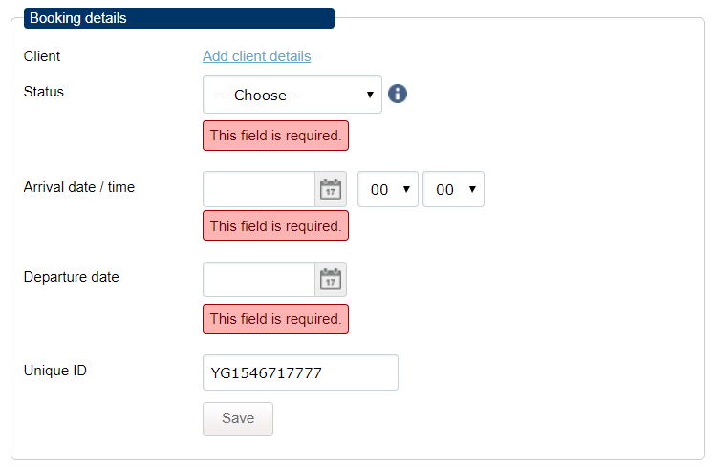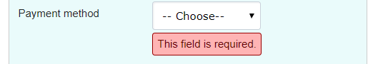

**3.1i. Required field warnings**

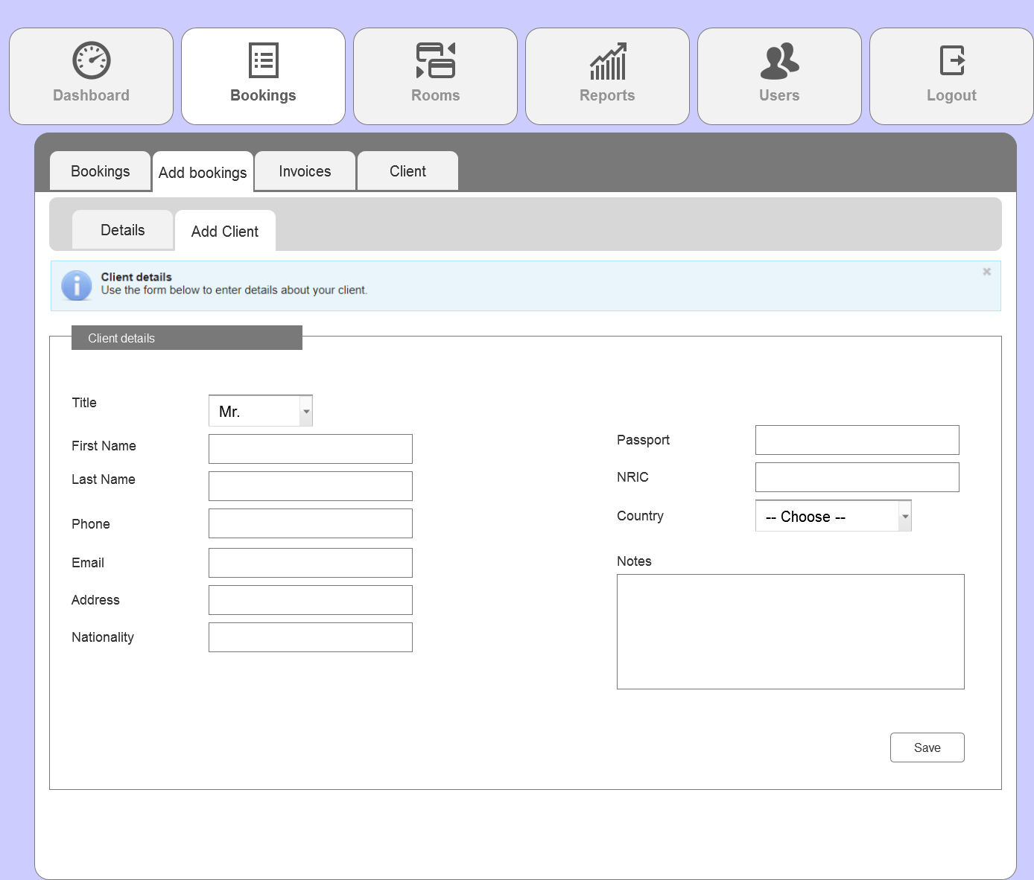

**3.2. Add client page**

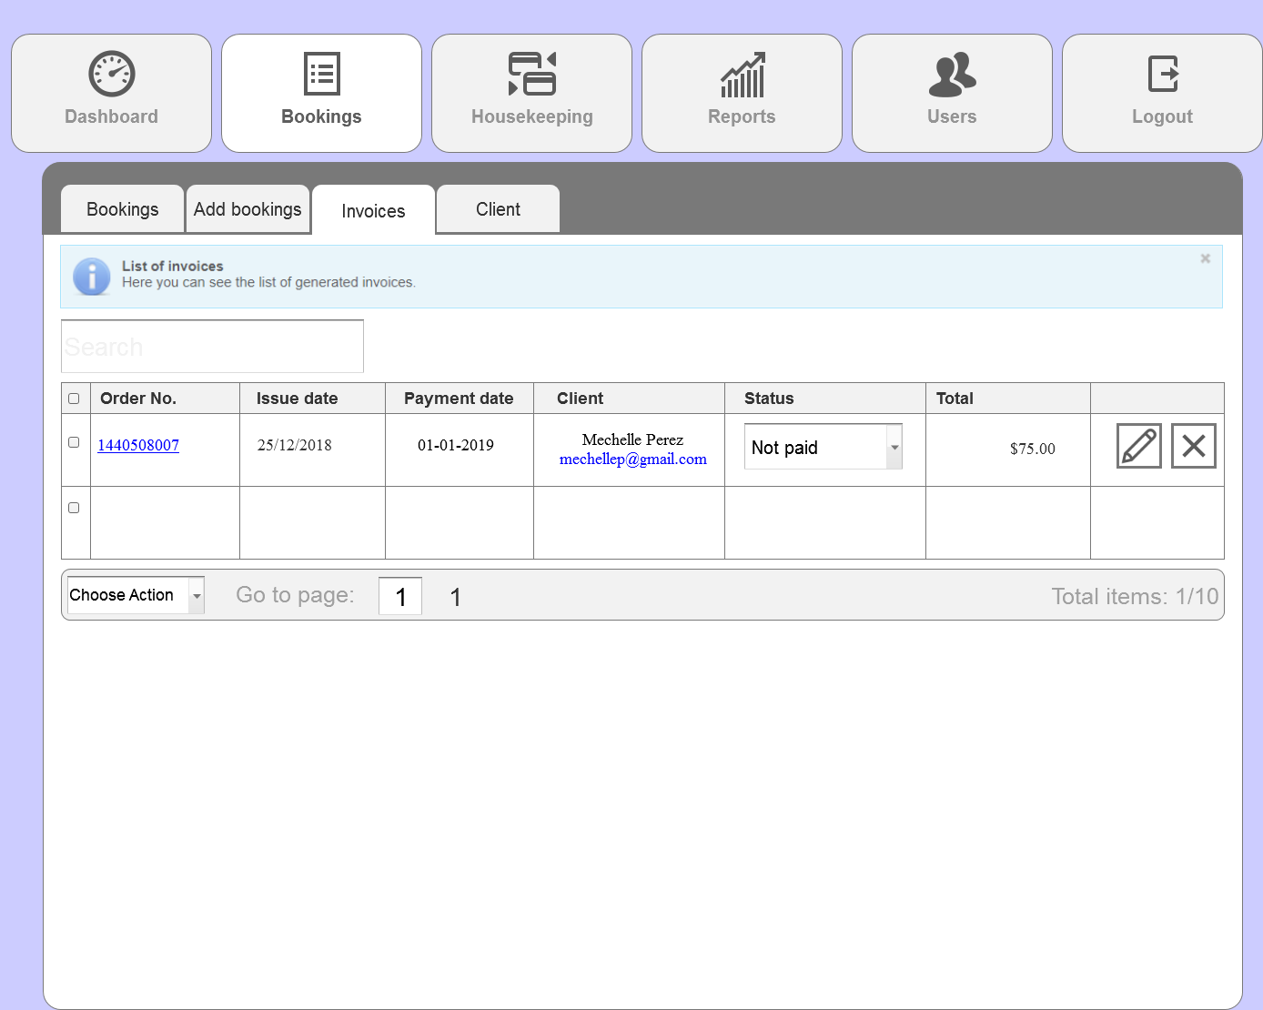

**4. Invoices**

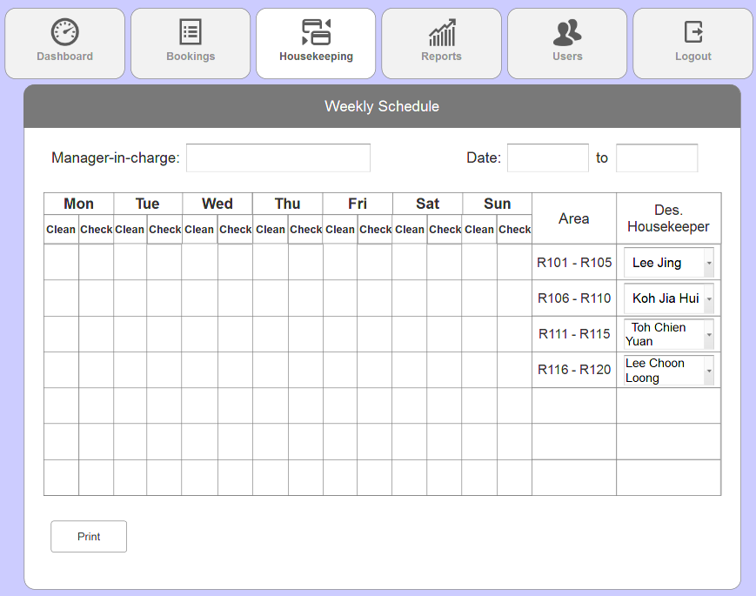

**5. Housekeeping schedule**

* Admin or the management staff will be the one allocating the designated housekeeper then print it out to let staff fill in accordingly.
* The designated housekeeper drop down list will look like (refer to 5i.)

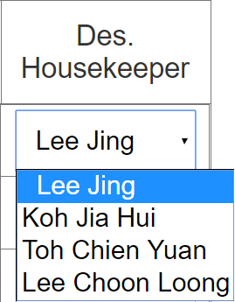

**5i. Designated housekeeper dropdown list**

* This drop down list will contain the names of all existing employees in the company (assuming that there’s 4 currently)

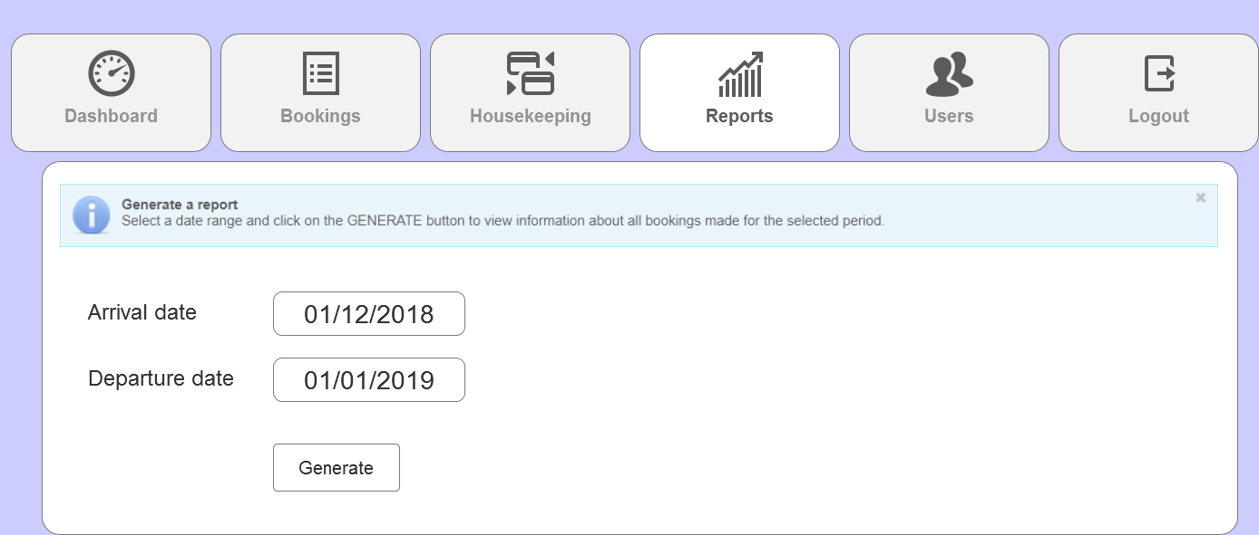

**6. Reports**

* User are to choose a date from the calendar field (refer to 6i.) to be able to generate a report
* After choosing and clicked on ‘Generate’ button, user will be shown a list of reports of the bookings and will be able to print (refer to 6.1.)

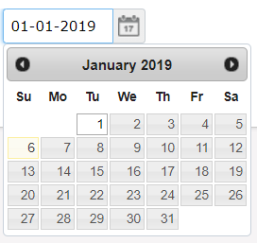

**6i. Calendar field**

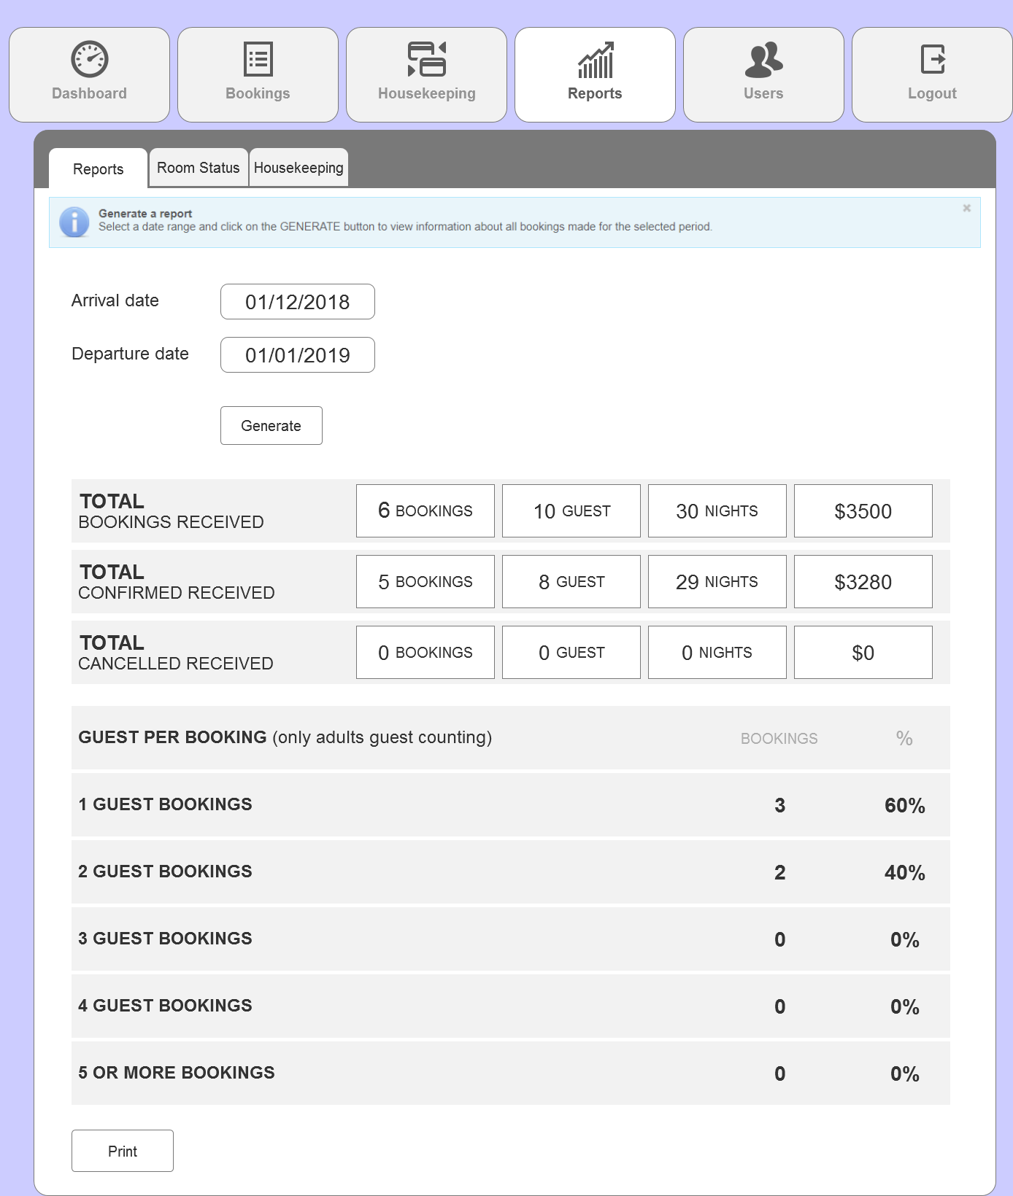

**6.1. Reports (cont.)**

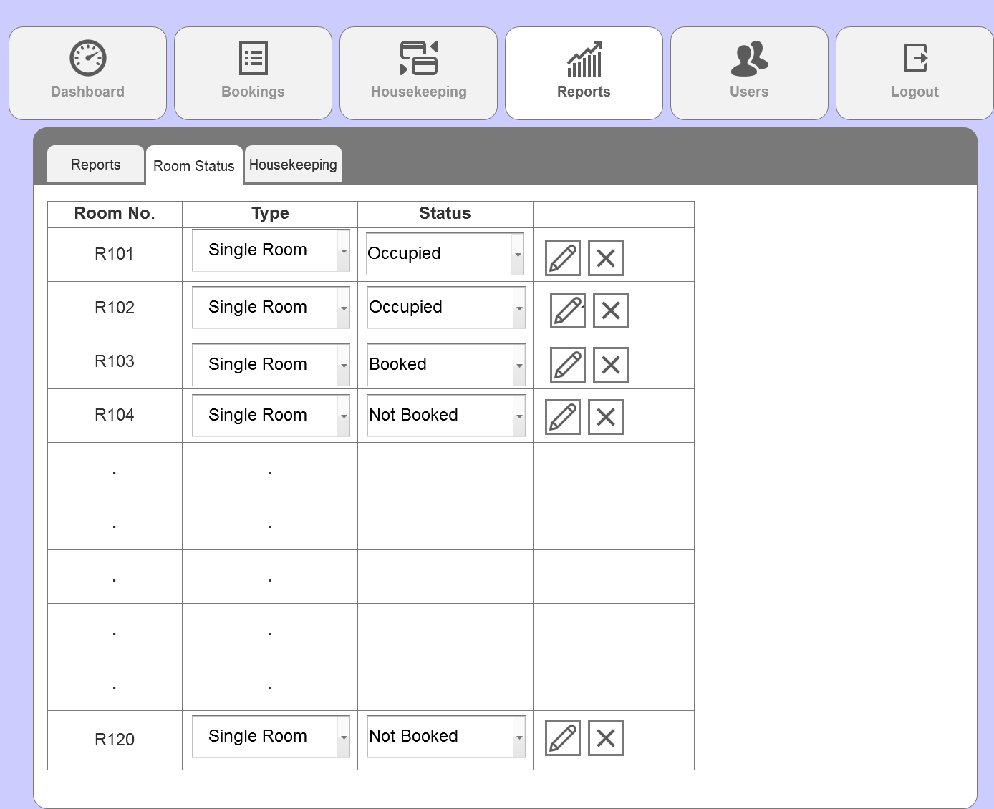

**6.2. Reports (Room Status)**

* Room status page will display **all** rooms with their status either Occupied, Booked of Not Booked.
* Users can edit the type of room (currently only Single Room available) and guest from the drop down list, and the status of the room by clicking on the edit icon.

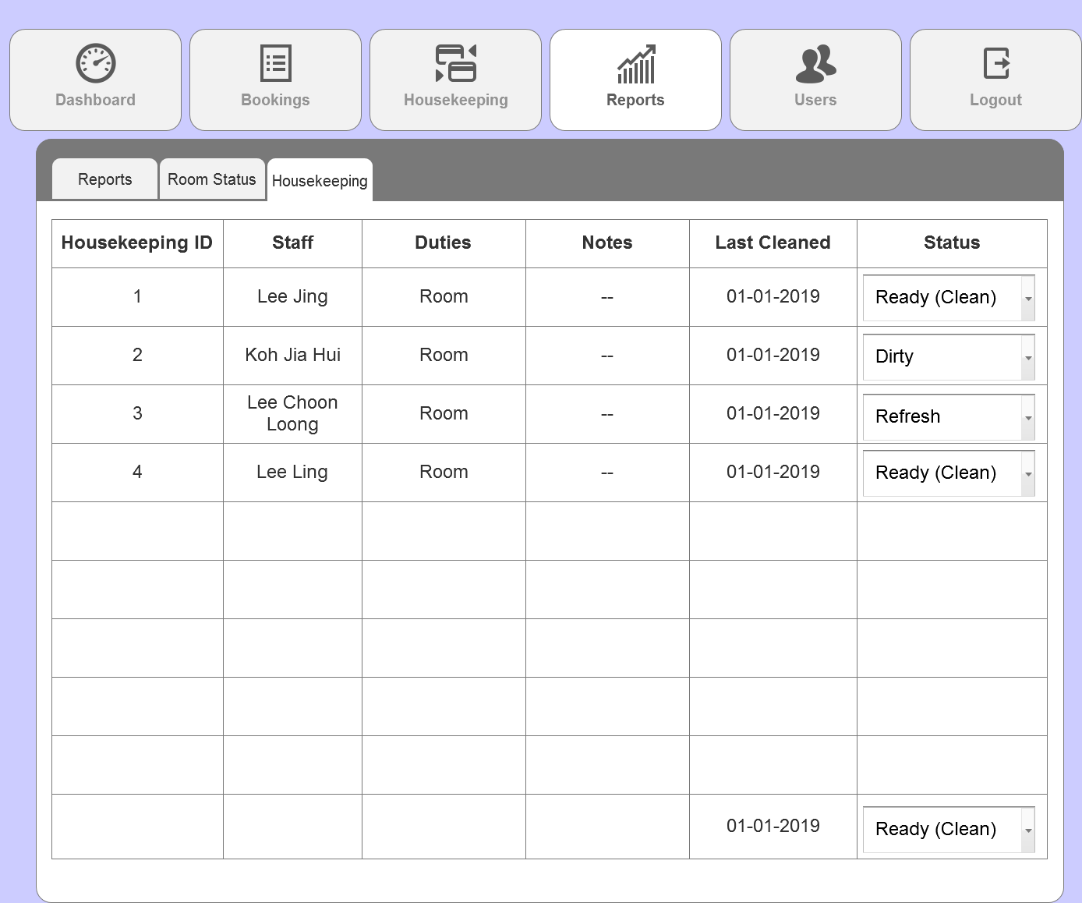

**6.3. Reports (Housekeeping)**

* User can edit the status of housekeeping from the drop down list to either Ready (Clean), Dirty or Refresh.

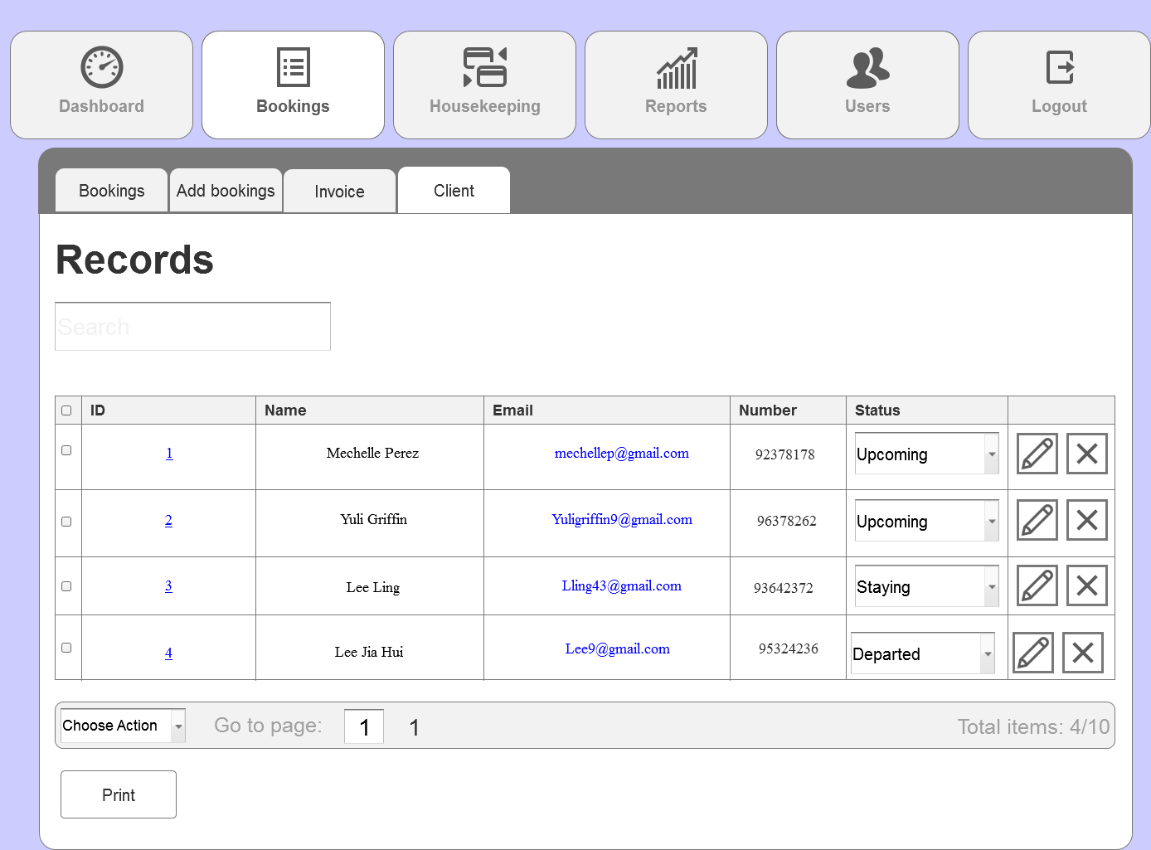

**7. Booking (Client)**

* This page shows all records of client that made reservations.

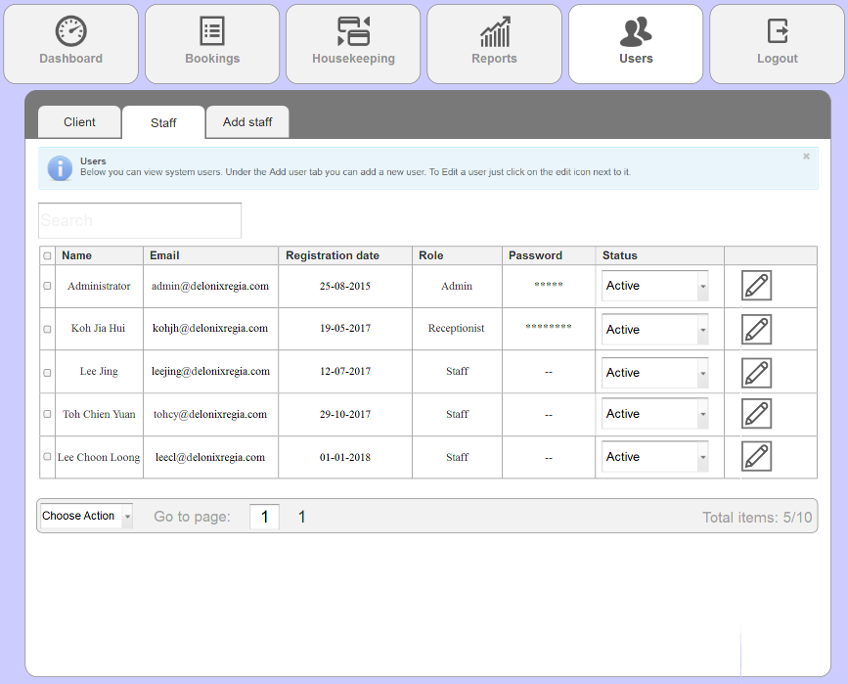

**7.1. Users (Staff)**

* This page shows all records of the current employees in the company
* Only admin and receptionist have password as they will be accessing the admin panel.

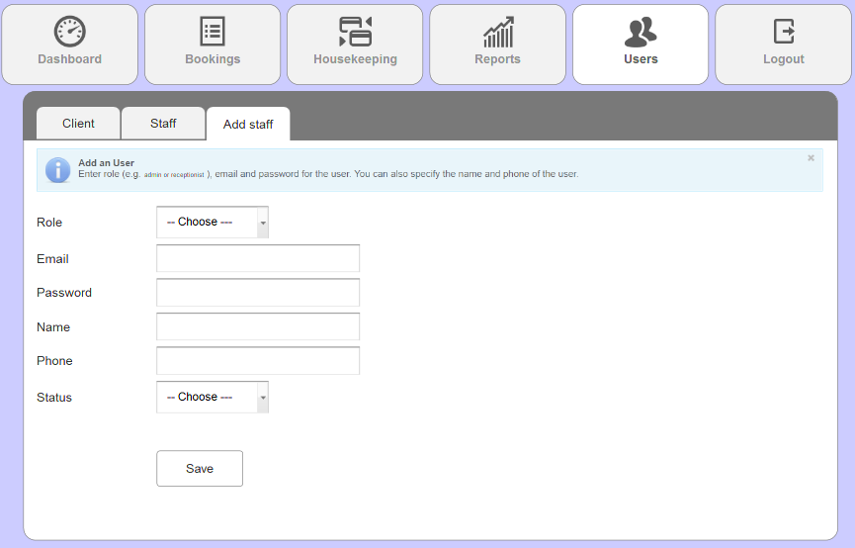

**7.2 Users (Add staff)**

User will be redirected back to the admin panel login page upon clicking the logout tab.

# 

# PROGRAM DESIGN

Room Availability and Booking Module

Main Flow:

Guest reserves room.

System receives the reservation request.

Guest enters their details.

Receptionist accesses and edits reservation details.

Receptionist checks guest details.

Receptionist checks in guests.

Receptionist checks out guests when they leave.

Alternative Flow:

Guest reserves room.

System receives the reservation request.

System informs guest that the room is not available currently.

System informs guest to choose other available rooms.

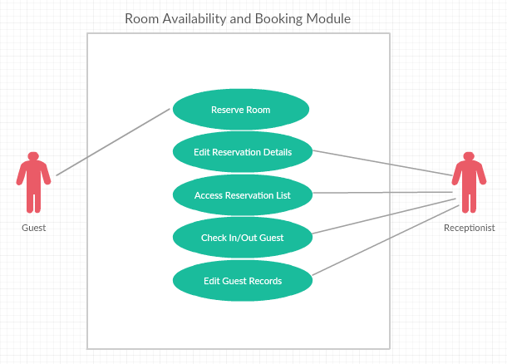

Housekeeping and Staff Management Module

Main Flow:

Management Staff assigns duties.

Housekeeping Staff receives duties.

Housekeeping Staff completes duties.

Management Staff delete duty when the tasks are completed.

Alternative Flow:

Management Staff assigns duties.

Housekeeping Staff receives duties.

Housekeeping Staff failed to complete duty (eg. room not cleaned properly).

Management Staff edits duty for staff to redo duty.

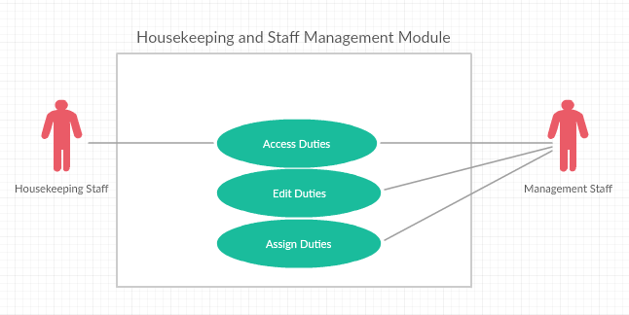

Reporting Module

Main Flow:

Module generates room status report.

Module generates ‘number of guests in one room’ report.

Module generates ‘number of guests in one room in one day’ report.

Module generates room occupancy report.

Module generates housekeeping report.

Module generates ‘room occupancy’ and ‘housekeeping reports daily, weekly, monthly and yearly.

Module allows user to preview reports before printing.

Alternative Flow:

Module generates room status report.

Administrator realises room status report is inaccurate.

Administrator updates room report.

Module re-generates room status report.

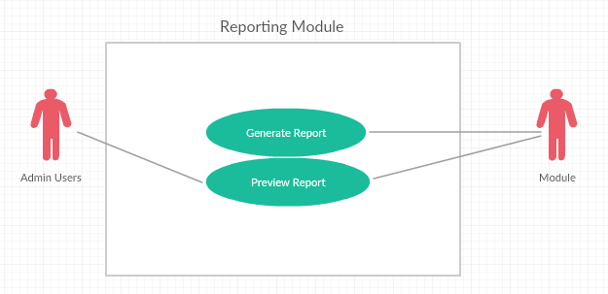

User Access Control

Main Flow:

Administrator adds employee.

Administrator enters employee details.

Administrator updates employee details.

Administrator deletes employee details after employee quits.

Alternative Flow:

Administrator adds employee.

Administrator enters employee details.

Administrator enters wrong employee information.

Administrator updates employee details.

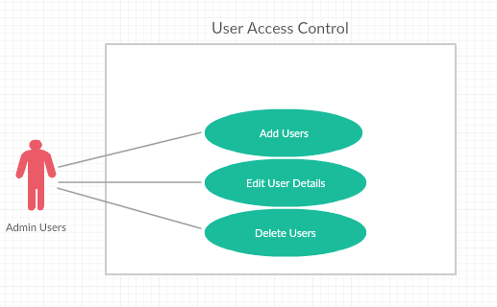

# DATABASE DESIGN

# Table Name: Booking Table.

# Description: This table contain of booking detail.

|  |  |  |  |  |  |  |  |
| --- | --- | --- | --- | --- | --- | --- | --- |
| **Field Name** | **Data Type** | **Field Size** | **Primary/**  **Foreign Key**  **(P/F)** | **Nullable**  **(Yes/No)** | **Unique**  **(Yes/No)** | **Description** | **Example** |
| booking_id | INT | 11 | P | N | Y | ID of booking | 1440508810 |
| customerID | INT | 11 | F | N | N | ID of customer | 1 |
| datetimeBooking | datetime |  |  | N | N | Date and time when create reservation | 25/02/2019, 12:20AM |
| num_adult | INT | 11 |  | N | N | Number of Adult | 2 |
| num_children | INT | 11 |  | N | N | Number of Children | 0 |
| status | Varchar | 50 |  | N | N | Booking status | Confirmed |
| paymentID | INT | 11 | F | N | N | ID of payment | 1 |
| roomNum | INT | 11 |  | N | N | Room number that is assign to the guest | R21 |
| checkinDateTime | Datetime |  |  | N | N | Check in date & time | 14/02/2019 , 9:00AM |
| checkoutDateTime | Datetime |  |  | Y | N | Check out date & time | 25/02/2019 , 12:00PM |
| add_remarks | Text | 300 |  | Y | N | Additional remarks | King size bed |
| lateCheckout | Boolean |  |  | N | N | Indication of late checkout | 1 |

# 

# Table Name: Staff.

# Description: This table contain of Staff detail.

|  |  |  |  |  |  |  |  |
| --- | --- | --- | --- | --- | --- | --- | --- |
| **Field Name** | **Data Type** | **Field Size** | **Primary/**  **Foreign Key**  **(P/F)** | **Nullable**  **(Yes/No)** | **Unique**  **(Yes/No)** | **Description** | **Example** |
| staff_id | INT | 11 | P | N | Y | ID of staff | 1 |
| name | Varchar | 100 |  | N | N | Staff’s name | May Cheong |
| phone_num | INT | 11 |  | N | Y | Staff’s phone number | +6594562587 |
| email | Varchar | 100 |  | N | Y | Staff’s email | MayC@hotmail.com |
| address | Text | 400 |  | N | N | Staff’s address | 91 Paya Lebar Way, Singapore 370091 |
| position | Varchar | 100 |  | N | N | Staff’s position in the company | Manager |
| dateJoin | DATE |  |  | N | N | Date when the staff joined the company | 25/1/2017 |
| bankAccount | Varchar | 50 |  | N | Y | Staff’s bank account number | 501-12395-6001 |
| username | Varchar | 50 |  | N | Y | Staff’s username for login in authentication | MayCH |
| password | Varchar | 20 |  | N | N | Staff’s password for login in authentication | 1233 |

# 

# Table Name: Room table.

# Description: This table contain of Room detail.

|  |  |  |  |  |  |  |  |
| --- | --- | --- | --- | --- | --- | --- | --- |
| **Field Name** | **Data Type** | **Field Size** | **Primary/**  **Foreign Key**  **(P/F)** | **Nullable**  **(Yes/No)** | **Unique**  **(Yes/No)** | **Description** | **Example** |
| room_id | INT | 11 | P | N | Y | ID of room | 1 |
| room_num | INT | 11 |  | N | Y | Room’s number | 201 |
| room_type | Varchar | 50 |  | N | N | Room type | Suite |
| room_status | Varchar | 50 |  | N | N | Whether the room’s available or not | Not available |
| room_price | Decimal | 5,3 |  | N | N | Suite | $300 |

# 

# Table Name: Customer table.

# Description: This table contain of Customer detail.

|  |  |  |  |  |  |  |  |
| --- | --- | --- | --- | --- | --- | --- | --- |
| **Field Name** | **Data Type** | **Field Size** | **Primary/**  **Foreign Key**  **(P/F)** | **Nullable**  **(Yes/No)** | **Unique**  **(Yes/No)** | **Description** | **Example** |
| customer_id | INT | 11 | P | N | Y | ID of customer | 1 |
| title | Varchar | 10 |  | N | N | Title | Mr. |
| firstName | Varchar | 50 |  | N | N | Customer’s First Name | Choon Loong |
| lastName | Varchar | 50 |  | N | N | Customer’s Last Name | Lee |
| NRIC | Varchar | 50 |  | Y | Y | Customer’s NRIC number | S9645823B |
| Passport | Varchar | 50 |  | Y | Y | Customer’s Passport number | K0000000B |
| Nationality | Varchar | 50 |  | N | N | Customer’s nationality | Singaporen |
| phone_num | Varchar | 50 |  | N | Y | Customer’s phone number | +6596542548 |
| email | Varchar | 100 |  | N | Y | Customer’s email address | Coolloongloong@hotmail.com |
| address | Text | 400 |  | N | N | Customer’s address | 684 Race Course Road, #13-102, singapore 210684 |
| credit_num | Varchar | 50 |  | Y | N | User’s credit number | 4111111111111111 |
| creditName | Varchar | 50 |  | Y | N | User’s name | Lee Choon Loong |
| creditExp | Date |  |  | Y | N | User’s credit card’s expiry date | 04/22 |

# Table Name: Housekeeping table.

# Description: This table contain of Housekeeping detail.

|  |  |  |  |  |  |  |  |
| --- | --- | --- | --- | --- | --- | --- | --- |
| **Field Name** | **Data Type** | **Field Size** | **Primary/**  **Foreign Key**  **(P/F)** | **Nullable**  **(Yes/No)** | **Unique**  **(Yes/No)** | **Description** | **Example** |
| housekeeping_id | INT | 11 | P | N | Y | ID of House keeping | 1 |
| staff_Id | INT | 11 | F | N | N | Staff’s ID | 1 |
| status | Varchar | 50 |  | N | N | Room’s status | Done |
| room_Id | INT | 11 | F | N | N | Room’s ID | 23 |
| duty_type | Varchar | 50 |  | N | N | Type of duty | Room |
| schedule | DateTime |  |  | N | N | Time for stuff to do the duty | 23/12/2018 1:00pm |
| remarks | Text | 300 |  | Y | N | Additional remarks | Extra bed. |

# 

# Table Name: Payment table.

# Description: This table contain of Payment detail.

|  |  |  |  |  |  |  |  |
| --- | --- | --- | --- | --- | --- | --- | --- |
| **Field Name** | **Data Type** | **Field Size** | **Primary/**  **Foreign Key**  **(P/F)** | **Nullable**  **(Yes/No)** | **Unique**  **(Yes/No)** | **Description** | **Example** |
| payment_id | INT | 11 | P | N | Y | ID of Payment | 144050800 |
| totalCost | Decimal | 5,2 | F | N | N | Total cost | $500 |
| num_night | INT | 11 |  | N | N | Number of night | 3 |
| paymentType | Varchar | 20 |  | N | N | Cash or credit card | Cash |
| additionalCost | Decimal | 5,2 |  | Y | N | Additional cost. | $100 |
| booking_ID | INT | 11 | F | N | Y | Booking ID | 1 |
| customer_ID | INT | 11 | F | N | N | Customer ID | 1 |
| dateIssue | date |  |  | N | N | Date when invoice is generated | 23/05/2016 |
| date | DATE |  |  | N | N | Date of payment | 23/05/2016 |

# 

# REFERENCES

3-Tier Architecture: A Complete Overview. (n.d.). Retrieved January 3, 2019, from <https://www.jinfonet.com/resources/bi-defined/3-tier-architecture-complete-overview/>